# 

**COR-1305 Spreadsheet Modelling and Analytics**

**Recommendation for Ideal HDB Resale Flat & Possible Financing Options**

**Team: G4T4**

Members:

Adrianus Tjoatja Widjaja

Chin Jia Xuan

Enqi Chan

Loh Yi Tern Hansel

Yeo Zhi Wei

Contents

**Problem Statement and Study Justification 3**

**System Scope and User Functionalities 3**

**Performance Measures and Their Evaluations 3**

HDB Recommendation Model 3

Loan Recommendation Model 4

**Data Collection and Analysis 5**

Data Collection for Resale Flat 5

Data Collection for MRT, Schools and Malls Data 5

Data Collection for HDB Grants and HDB & Financial Institute Loans 6

Data Pre-processing and Analysis 6

**Decisions and Alternatives 7**

Decisions 7

Alternatives 7

**Model Sketches 8**

Influence diagram & Black Box Model for HDB Recommendation 8

Influence diagram & Black Box Model for Loan Recommendation 8

**Trade-offs, Scenarios and Sensitivity Analysis, and their Results and Implications 9**

Trade-offs 9

Scenarios 10

HDB Recommendation Model 10

Loan Recommendation Model 11

Sensitivity Analysis 11

**Model Limitations, Lessons Learnt and Conclusions 11**

**Member’s Role 12**

**References 13**

# 

# 

# 

# Problem Statement and Study Justification

The market offers a plethora of resale HDBs, making homebuyers spoilt for choice (HDB, 2023). Purchasing a home is a significant financial commitment (OCBC, 2018), demanding meticulous consideration, especially with rising resale flat prices (Ng, 2023). Although existing housing recommendation platforms aid potential homebuyers in choosing suitable properties in the market, they lack customizability and personalisation, overlooking individual preferences and priorities. Moreover, purchasing a house does not simply end at identifying a suitable home. There are other considerations that have to be taken into account, such as the user’s eligible housing grants, and a suitable loan plan to finance their home. This adds another layer of complexity for homebuyers.

Our project aims to address this gap with an all-in-one platform, assisting first-time HDB homebuyers from the beginning to the end of their considerations and decisions process to purchase their ideal home. This eliminates the need for our users to peruse through multiple platforms when deciding on the ideal flat to purchase. Our solution consists of 2 models: the first will provide HDB resale flat recommendations based on the user’s preferences; the second will provide the optimal financing housing loan option based on their HDB grant eligibility.

Research has shown that location and amenities, such as nearby MRTs, education institutions, and malls, play an important role in homebuyers’ decisions (Sun, 2023; J., 2020). Hence, we will be taking these factors into consideration. Additionally, not all resale flat homebuyers will be eligible for the HDB Loan scheme (HDB, 2023), thus our solution will also encompass the different financial institutions that homebuyers can loan from.

# System Scope and User Functionalities

In the first model, our system will recommend the top 5 resale HDBs based on the user’s budget and their HDB preferences. The system will allow for filtering of preferences, and customising the recommendation based on their prioritisation of some of the quantitative preferences.

In the second model, our system will recommend the most suitable housing loan plan based on the user’s selected HDB from our top 5 recommendations. Users will be informed of the housing grants they are eligible for, and the estimated total price of the resale HDB after taking into account the eligible grants. The user can change the loan repayment period for the HDB and bank loan schemes individually, which provides flexibility in helping them decide the most suitable housing loan plan. The following flow chart is an overview of the user journey:

***Figure 1****: User Journey*

# Performance Measures and Their Evaluations

## HDB Recommendation Model

The housing model employs a filtering mechanism to discern and compute the top 5 optimal housing choices tailored to each user's unique preferences and priorities. The performance measures for this first model are the Prices of Flats, Average Walking time to amenities, remaining lease of flats, floor area of flats and the preference score. The higher the preference score, the better it matches the user’s prioritisation.

We will first filter to find the list of flats that meet the user’s criteria. Next, for the remaining specified preferences, the model undertakes a calculation involving the standardisation of the value of the preferences multiplied by its designated weightage. As each factor has different units with different scales, it is important to standardise them so that they can be compared more fairly. We have decided to standardise the ‘Remaining Years’ and ‘Floor Area (sqm)’ by dividing it by the maximum value of the shortlisted flats. This is because the maximum value for each factor represents the most ‘ideal’ situation, where the closer the value is to the maximum, the higher it is regarded. However, for ‘Average Walking Time to nearest amenities’ and ‘Resale Price’, we have to take into consideration that a smaller number is preferred. Thus, if we directly use its value to calculate the score, the smaller value would bring the preference score down even though it should have done the opposite. Therefore, we invert the scale before dividing it by the maximum value. An example of the calculation is provided below:

***Ranking and Weights:*** Rank 1: 50%, Rank 2: 35%, Rank 3: 15%

***Figure 2.1****: Standardisation Table*

|  | Remaining Years | Floor Area | Avg. Walking Time to nearest amenities | Flat Price |
| --- | --- | --- | --- | --- |
| Standardisation |  |  |  |  |

***Figure 2.2****: Preference Scoring table*

|  | Preference Rank 1 | Preference Rank 2 | Preference Rank 3 |
| --- | --- | --- | --- |
| **Ranking | 1 | 2 | 3 |
| **Weighting | 50% | 35% | 15% |
| Value | V1 | V2 | V3 |
| *Standardisation | S1 | S2 | S3 |
| Score | S1*50% = X | S2*35% = Y | S3*15% = Z |
| **Refer to rankings for the relevant weighting  *Refer to Table 1 for standardisation calculation | | Preference Score: | X+Y+Z |

***Figure 2.3****: Example of Preference Scoring*

| ***Flat example:*** *512 Ang Mo Kio Avenue 8, Floor 10-12, Flat Price: $538,000* | | | |
| --- | --- | --- | --- |
|  | Avg. walking time to nearest amenities | Remaining Lease Years | Floor Area |
| Ranking | 1 | 2 | 3 |
| Weighting | 50% | 35% | 15% |
| Value | 5 | 56 | 93 |
| Standardisation |  |  |  |
|  |  | Preference Score: | A+B+C |

## Loan Recommendation Model

The loan model takes into account the user’s financial information and preferences, then recommends the best housing loan scheme. The performance of this second model is evaluated based on 3 key factors: the total amount of interest paid, the user's eligibility status and whether the monthly repayment sum exceeds the validated budget.

The ideal recommendation is a loan plan that not only meets the user's eligibility requirements and the validated monthly repayment budget but also incurs the lowest possible total interest payment among all eligible options. The following shows an example of how our model determines the best loan plan, by selecting the option with the lowest total interest paid from all the plans that meet the validated monthly repayment budget and that the user is eligible for:

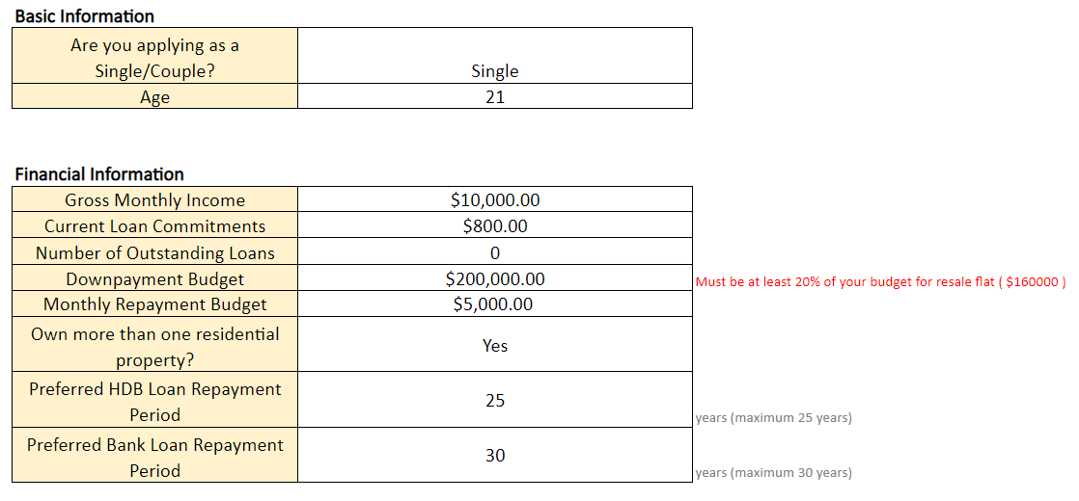

***Figure 3.1****: Example user input*

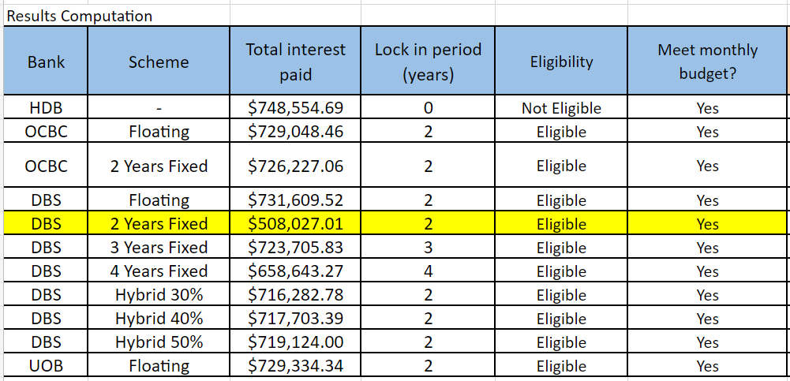

***Figure 3.2****: Ideal Loan Plan Analysis based on the example input above*

# Data Collection and Analysis

## Data Collection for Resale Flat

Our team has decided to use the ‘Resale Flat Prices’ data from the government website beta.data.gov.sg (Open Government Products, 2021). We have chosen to use only data of resale flat prices in October 2023, as we have decided that it is the most relevant substitute for a live dataset.

## Data Collection for MRT, Schools and Malls Data

The datasets for MRT, schools and malls were found on Kaggle. We used the ‘Singapore MRT & LRT Stations with Coordinates’ dataset, which contains a list of MRT and LRT stations with their individual latitude and longitude coordinates (Sheng, 2019). We will also be using the ‘General Information of Schools’ dataset, which contains a list of schools around Singapore, as well as the addresses of these schools (Surana, 2021). Finally, we will be using the ‘Shopping Mall Coordinates’ dataset, which contains a list of shopping malls around Singapore, along with their latitude and longitude (Gangula, 2023).

## Data Collection for HDB Grants and HDB & Financial Institute Loans

We have extracted the list of HDB Grants and loans available from the official HDB website. We have also compiled loan schemes from the official websites of Singapore's top three local banks: DBS, OCBC, and UOB (Théaud, 2023), which are also listed as approved financial institutions by the Monetary Authority of Singapore (MAS, 2023). These data are populated in the relevant tables and are used to calculate the grants and loans that homebuyers are able to receive. We also had to gather the Loan-To-Value (LTV) limits guideline in order to calculate the minimum down payment amount required (MAS, 2018).

## Data Pre-processing and Analysis

**Flat Recommendation Model:**

For the resale flats dataset, we added in a column for the coordinates of the flat locations. We retrieved the coordinates by extracting the data into a Python file, using the OpenMap API (OneMap Singapore, n.d.) to generate the coordinates. We will use Python to add the coordinates to new columns and save the file as a csv file. Similar to the resale flats dataset, we intend to generate the coordinates of the locations of schools. For all datasets, we will remove columns which are not relevant to our models.

Next, we created a table ‘Distance to Time Conversion’, to match a range of distances (in metres) to the estimated amount of time needed to cover this distance at a walking speed of 4.5km/h, which is approximately the same walking speed as provided by Google Maps (Google, 2021). We used the Euclidean distance between the coordinates of each resale flat and the possible amenities, to find the nearest amenities. We then used the Haversine formula and calculated the shortest distance between the flat and each amenity, and subsequently used Excel’s VLOOKUP function to find the approximate walking time needed.

Finally, we will link the datasets together through the use of formulas to calculate the distance of these flats from the nearby schools, MRT stations and malls. We will use the coordinates to find the shortest distance and subsequently match the distance to the amount of time needed.

**Loan Recommendation Model:**

We conducted validation on the user’s down payment budget using the final flat cost and the LTV guideline. Firstly, we derived the user’s grant eligibility from their input information such as age and proximity to their parents home. Next, we will calculate the final cost of the flats after taking into account the grants that they are eligible for. Then we ensured that the user’s down payment budget have met the minimum down payment percentage for HDB and bank loans respectively, by re-adjusting their input with the LTV guideline.

We also conducted validation on the user’s monthly mortgage repayment budget, by calculating the maximum monthly repayment loan amount based on the Mortgage Servicing Ratio (MSR) and Total Debt Servicing Ratio (TDSR).

For the pre-processing of the bank loan plans, we documented the eligibility criteria and interest rates associated with each scheme. A prevalent trend among these plans was the utilisation of the 3M Compounded SORA (Singapore Overnight Rate Average) value in their interest rate computations. This resulted in floating interest rates and we could not use fixed interest rate calculations which we were more familiar with. To mitigate complexities, we decided to standardise our approach by using the current 3M Compounded SORA value as of October 2023.

# Decisions and Alternatives

## Decisions

For the ranking weightage, we decided on the following allocation: Rank 1 - 50%, Rank 2 - 35% and Rank 3 - 15%. We derived the following percentages by assigning 1 unit of importance to additional rankings. For example, Rank 3 will start from 1 unit of importance, followed by Rank 2 with 2 units of importance and lastly Rank 1 with 3 units of importance. As the total percentage must match up to 100%, Rank 1 will be calculated to be 50% (3/6), Rank 2 will rounded up 35% (2/6), and Rank 2 will be rounded down to 15% (1/6). This systematic allocation of weightage allows for a nuanced assessment that aligns with the specific priorities and objectives of the valuation process.

We also fixed the number of rankings to 3, as allowing users to rank more options would dilute the weightage of each factor, diminishing the effectiveness of our model. For the options available for ranking, our team decided to exclude the location, flat type and unit floor level, as these values are qualitative and subjective. Thus, it is difficult to quantify and calculate the overall standardised score.

## Alternatives

We recognize the existence of alternative solutions like PropertyGuru, which enables users to filter available resale flats according to their preferences such as location and number of bedrooms. However, what sets our model apart is its consideration of user preference ranking priority. We customise our recommendations to the specific needs of the user, presenting options in order of the most "value for money" flat based on their ranking. This personalised approach distinguishes our model, ensuring a more tailored and user-centric housing recommendation experience.

We also acknowledge that official websites like HDB and various banks have their own systems to assist users in calculating suitable loan schemes. However, they lack the ability to determine the user’s grant eligibility and to calculate the final price of the flat after considering the eligible grants. Our model thus offers an all-in-one platform that facilitates the cross-comparison of loan plans across different institutions. In contrast to the individual tools provided by official sources, our platform streamlines the process, enabling users to assess multiple loan options conveniently within a single interface.

# Model Sketches

## Influence diagram & Black Box Model for HDB Recommendation

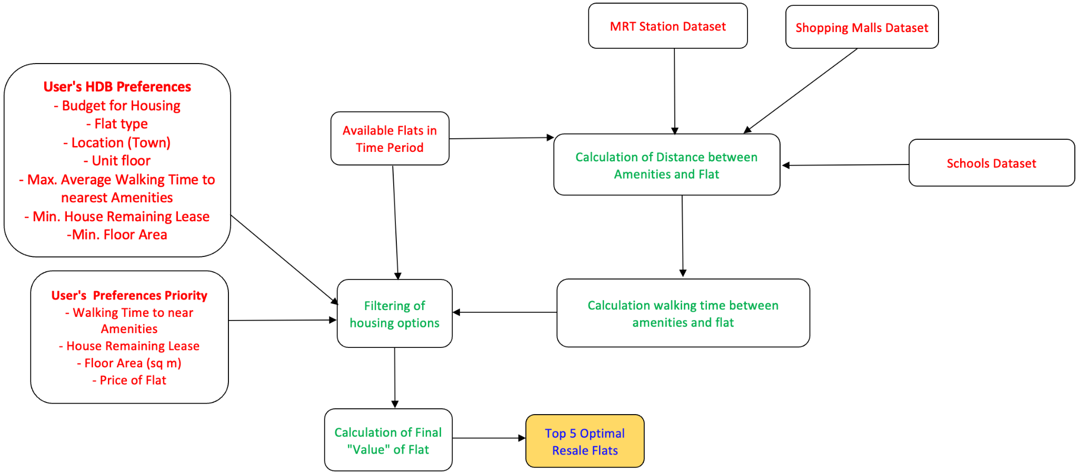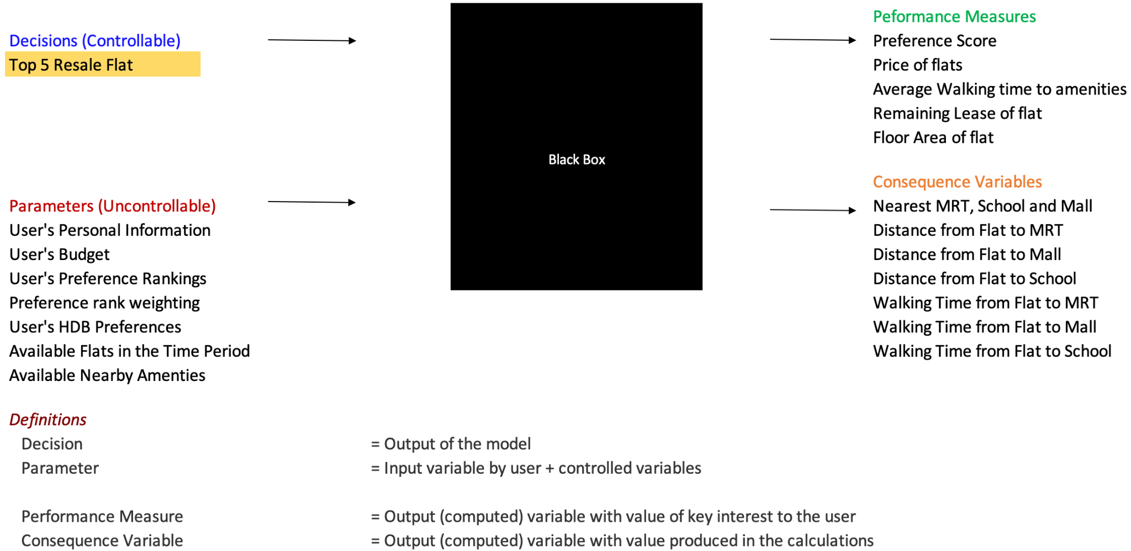

## Influence diagram & Black Box Model for Loan Recommendation

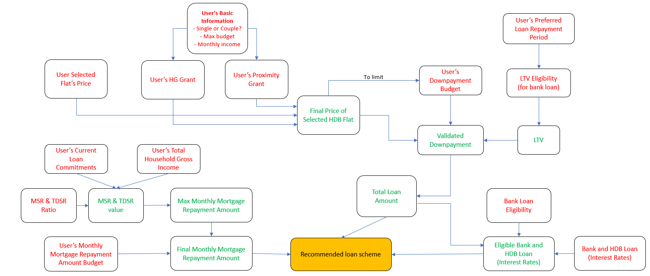

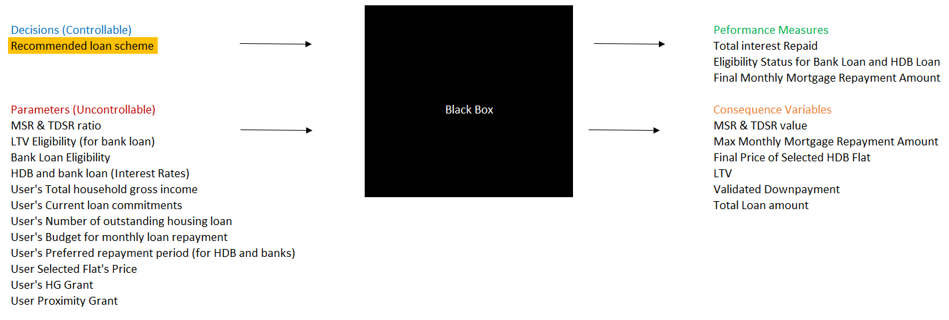

# Trade-offs, Scenarios and Sensitivity Analysis, and their Results and Implications

## Trade-offs

We decided to conduct an analysis to determine if there is a trade-off between resale flat prices and the average walking duration to the nearest amenities: MRT, shopping mall, and school. We believe this would benefit the user by helping them effectively plan their budget according to their preferences for how far they would want to be to the nearest amenities.

Below in Figure 4.1, is the trade-off analysis between the average resale flat price and the average walking duration from the nearest amenity. From the figure, we can see that the average price of a flat will decrease as the average walking duration increases. We also found that the correlation coefficient is -0.92, which indicates that there is a strong negative relationship between both variables. Additionally, the regression suggests that for every unit increase in walking time bins, the average flat price is expected to decrease by $57,822. With a high R-squared value of 0.85, we can be confident that the regression line is a good fit for the data points.

From this analysis, users will gain useful insights into how the price of their desired flat fluctuates according to how far away it is from the nearest amenity, thus allowing them to make a more informed decision when choosing their desired flat.

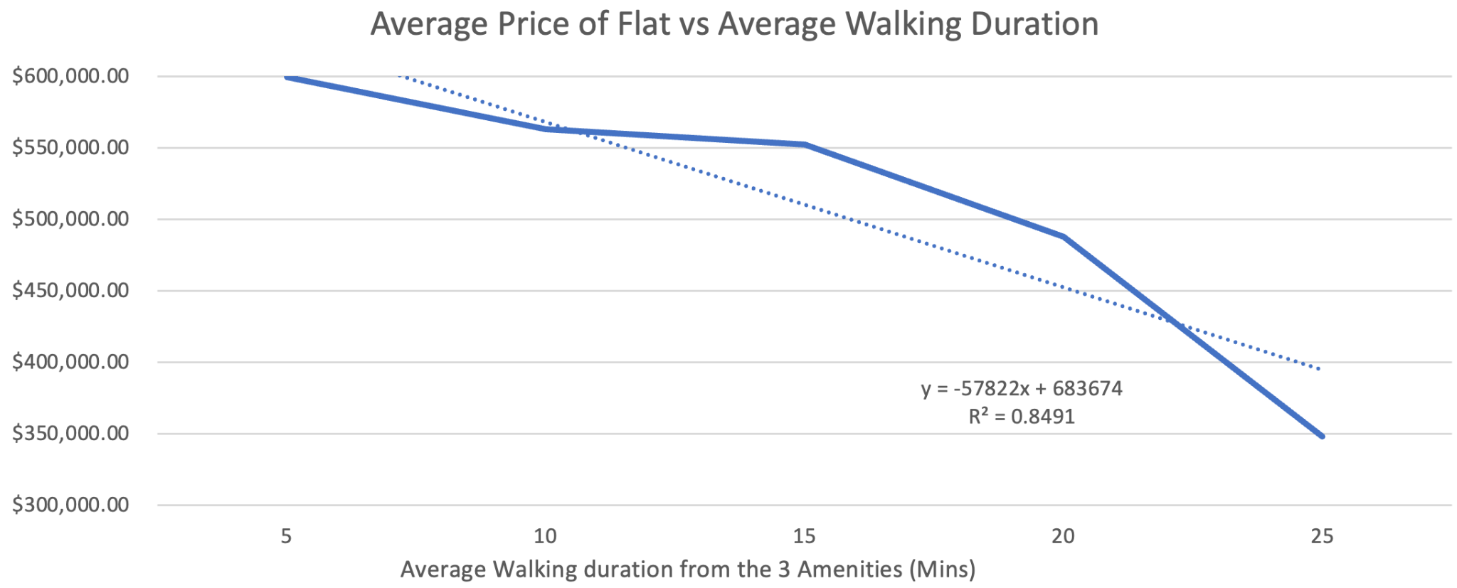

***Figure 4.1:*** *Trade-off analysis for flat price and walking duration*

Next, we decided to conduct another analysis to determine if there is a trade-off between the preferred loan tenure and the monthly mortgage repayment amount while keeping the other variables constant. We believe this analysis would be beneficial for the user in helping them to plan their loan accordingly as the longer the loan tenure, the more interest the user has to pay the bank or HDB.

From Figure 4.2 below, we can see that there is a trade-off between the duration of the loan and the affordability of monthly payments. The correlation coefficient is -0.9, which indicates that there is a strong negative relationship between both variables. This trade-off becomes especially evident when analyzing the financial implications for the user. Opting for a shorter loan tenure reduces the total interest paid over the loan's duration, thus saving the user a significant amount in the long run. However, this results in higher monthly payments, demanding a larger portion of the user's monthly budget. On the other hand, selecting a longer loan tenure lowers the monthly mortgage repayment amount, providing immediate relief to the user's finances. Yet, this convenience comes at a cost – a higher total interest payment over the extended period. Hence, the decision between a shorter or longer loan tenure becomes a pivotal one. This analysis illuminates the dynamic interplay between loan tenure and monthly affordability, empowering users with crucial insights to make informed decisions aligned with their financial aspirations.

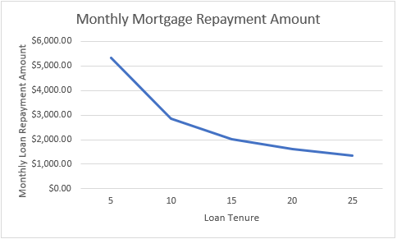

***Figure 4.2****: Trade-off analysis for tenure period and monthly mortgage*

## Scenarios

### HDB Recommendation Model

This model helps users identify the top 5 recommended flats that meet their individual preferences. Assume that a user enters a budget of **$700,000**, a preferred location of **Ang Mo Kio**, and a **4-room** flat type while keeping the other fields blank. The user also ranks their preferences in this order **1: Shorter average walking time to nearest amenities**, **2: Longer House Remaining Lease**, **3: Larger Floor Area**. Upon clicking the ‘Get Recommendations’ button, the top 5 flats should be seen as follows:

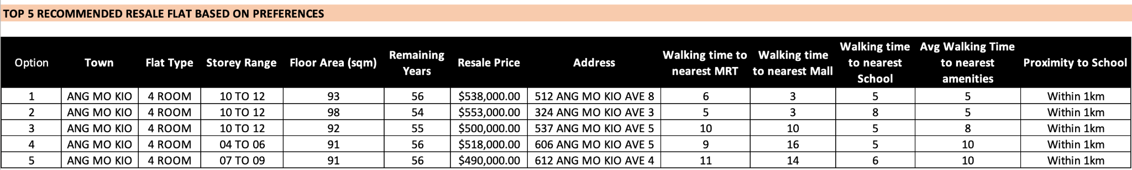

***Figure 5.1****: Example of output of Top 5 Recommendations*

Our model dynamically generates the top 5 flats based on all the user’s preferences. In the case where no flats are recommended, the user will be informed that there are no flats that match their preference this time round. Using the same example as above, if the user decides that he only wants the flat that has a maximum average walking time of 5 mins, the model will only churn out 1 result, as only this result fits his criteria:



***Figure 5.2****: Example of output of Top 5 Recommendation with only 1 output*

### Loan Recommendation Model

In the following scenarios, we will show how different inputs will lead to the different types of possible outputs, recommending either the HDB loan plan, bank loan plans or none. We are aware that it is possible for no loan plans to be recommended by our model, due to the user’s input. Hence, we will inform the user and advise them to change their input, by eitherlowering their housing budget, increasing their monthly loan repayment budget or decreasing their downpayment.

Assuming that the final cost of the flat is $485,000 and keeping all other variables the same:

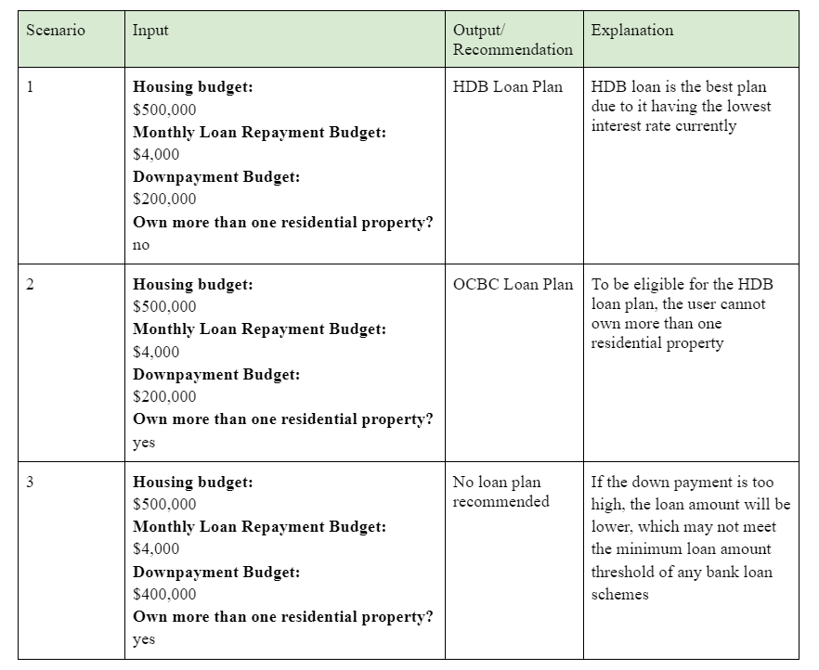

***Figure 5.3****: Table showing possible loan plan recommendations*

## Sensitivity Analysis

Initially, our intention was to conduct a sensitivity analysis regarding the weightage assigned to the 3 rankings (i.e., the decision to allocate 50% to Rank 1, 35% to Rank 2, and 15% to Rank 3). However, we recognized the need for a market sentiment analysis to proceed with this. The purpose of this sensitivity analysis was to determine how much we could adjust these percentages before users considered our HDB Recommendation model ineffective. Essentially, we aimed to understand the users' tolerance level for changes in the weightage of each ranking, assessing how much users would perceive our model as less useful when we narrowed the differences in rank weightage. To gather these valuable insights, conducting a survey among users was essential. Regrettably, due to time constraints, we were unable to conduct the necessary survey. Consequently, we concluded that performing a sensitivity analysis for the weightage of the 3 rankings was not feasible under the given circumstances.

# Model Limitations, Lessons Learnt and Conclusions

We selected Singapore Citizens who are first-time HDB buyers as our primary target audience, due to the added complexities involved in extending our scope to non-Singaporeans, such as grant eligibility. Within Singaporeans, we decided to broaden our target demographic to include both couples and singles, as focusing solely on either group would limit the scope of our project significantly.

A limitation of our HDB Recommendation model is that users will only be able to filter based on one option per preference (i.e. users can only filter the Location to ‘Ang Mo Kio’ and not ‘Ang Mo Kio and Bedok’). Our team attempted to use VBA, but due to time constraints and the lack of expertise, we decided to forgo this as it is not of high priority as of now. We hope to explore this option in the future and further improve our model.

We have identified another limitation in the HDB Recommendation model concerning the calculation of distances between each flat and the nearest amenity, which relies on Euclidean distance. Our model assumes that this measure accurately reflects the user’s walking time from the flat to the nearest amenity. However, real-world scenarios can involve obstacles or detours, leading to inaccuracies in both distance and walking time estimations.

Additionally, the 4 factors for prioritisation of the top 5 recommended flats are also a limitation. We were unable to find a more comprehensive resale flat dataset to include other factors, such as whether there are any nearby gardens etc. Due to the lack of variety in our model, our team decided to limit the factors for consideration and focus on the factors we found from our dataset. If given more time, our team hopes to be able to source for a more comprehensive dataset to provide users with a larger range of options when ranking their top 3 priorities, allowing for a more personalised recommendation.

For our Loan Recommendation model, it's important to note that we opted to focus on the top 3 banks in Singapore due to time constraints, rather than evaluating all 5-6 institutions. Additionally, the interest rates (affected by 3M SORA) used in the model are based on the latest available data as of October 2023. It's worth mentioning that interest rates for bank loans can change in real time due to factors like the 3M SORA. As such, the model provides insights based on the most recent data available but may not reflect real-time changes in interest rates. Lastly, our monthly mortgage calculation assumes interest rates change annually for the initial 4 years, which may result in less accuracy compared to monthly rate adjustments, especially for floating interest rate loans.

Designing this model was an interesting experience that allowed us to learn how to calculate floating interest rates. Having learnt about fixed interest rate calculations most of the time in school, this project gave us the opportunity to calculate fluctuating interest rates hands-on. We had to develop a calculation method entirely from scratch, based on our understanding of SORA, as there were limited resources for these calculations online.

In conclusion, this project has helped us to solidify our understanding of the various Excel functions we had learnt in class. It also helped us build a strong foundation in knowing when and how to apply these concepts in real life examples. This hands-on experience of using real data allowed us to bridge the gap between theory and real-world problems, demonstrating the significance of classroom learning in real-world scenarios.

# Member’s Role

**Adrianus Tjoatja Widjaja**: Researched and collated data on HDB Loan schemes. In charge of doing up the loan model for HDB loans. Did VBA and Data Validations to improve UI of User Input Sheet. Wrote trade-off analysis, limitations of the Loan model, and the black box and influence diagram.

**Enqi Chan**: Researched and collated data on Financial Institution Loan schemes. In charge of doing up the loan model for the top 3 Financial Institutes. Wrote problem statement and justification, Performance Measure and Evaluation, Scenario, trade-off analysis, sensitivity analysis and Model Limitations for Loan model.

**Chin Jia Xuan**: Found datasets and conducted data pre-processing for HDB resale flats. Calculated the distances between the flats and nearest amenities, and converted the distance into walking time. Created the model to find the nearest MRT, Schools and Malls, and the top 5 HDB recommendations and displayed them in the User Interface sheet. Wrote problem statement and justification, Performance Measure and Evaluation, Scenario, Model Limitations for HDB Recommendation model, Lessons Learnt, and did Black Box model for HDB Recommendation.

**Loh Yi Tern Hansel**: In charge of researching and collating all proximity grant eligibility for singles and couples. Handled trade off analysis for walking distance to amenity and resale flat price, and fine-tuned Model Limitations.

**Yeo Zhi Wei**: In charge of researching and collating all HDB Housing and Enhanced Housing grant eligibility for singles and couples. Collated all the required user inputs and formatted the User Input sheet. Handled trade off analysis for walking distance to amenity and resale flat price.

# References

Gangula, K. (2023). Shopping Mall Coordinates. Kaggle. <https://www.kaggle.com/datasets/karthikgangula/shopping-mall-coordinates>

Housing & Development Board (HDB). (2023). HDB | understanding your eligibility and Housing Loan Options. Housing and Development Board. HDB. <https://www.hdb.gov.sg/residential/buying-a-flat/understanding-your-eligibility-and-housing-loan-options>

Housing & Development Board. (2023, July 3). Upcoming Flat Supply and Flash Estimate of 2nd Quarter 2023 Resale Price Index. HDB. <https://www.hdb.gov.sg/about-us/news-and-publications/press-releases/03072023-2Q23-Flash-RPI>

J., R. (2020, June 16). 7 Factors To Help You Decide On The Best Location For Your Home. Stacked Homes. <https://stackedhomes.com/editorial/7-factors-best-location/#gs.6lp05y>

MAS. (2023). Financial Institutions Directory. MAS. <https://eservices.mas.gov.sg/fid/institution?sector=Banking&amp;category=Local+Bank>

MAS. (2018, July 5). Loan tenure and loan-to-value limits - monetary authority of singapore. MAS. <https://www.mas.gov.sg/regulation/explainers/new-housing-loans/loan-tenure-and-loan-to-value-limits?ref=patkoproperty.com>

Ng, M. (2023, August 10). HDB resale prices rise at slower pace of 0.3% in July; sales volume bounces back. The Straits Times. <https://www.straitstimes.com/singapore/housing/hdb-resale-prices-up-by-slower-pace-of-03-in-july-volume-bounces-back>

OCBC. (2018, July 12). 5 Of The Biggest Bills You Will See In Your Lifetime As A Singaporean. Frank by OCBC. <https://www.frankbyocbc.com/blog/5-of-the-biggest-bills-you-will-see>

OneMap Singapore. (n.d.). OneMap API Documentation. OneMap. <https://www.onemap.gov.sg/apidocs/>

Open Government Products. (2021, July 28). Resale Flat Prices. GovTech. <https://beta.data.gov.sg/collections/189/datasets/d_8b84c4ee58e3cfc0ece0d773c8ca6abc/view>

Sheng, J. (2019, March 9). Singapore MRT & LRT Stations with Coordinates. Kaggle. <https://www.kaggle.com/datasets/shengjunlim/singapore-mrt-lrt-stations-with-coordinates/>

Sun, C. (2023, August 11). Homing in on hot property near good schools. The Straits Times. https://www.straitstimes.com/business/invest/homes-that-are-near-good-schools-are-hot-properties

Surana, S. (2021, August 5). Schools Information & Directory (Singapore). Kaggle. <https://www.kaggle.com/datasets/subhamjain/schools-information-directory-singapore?select=general-information-of-schools.csv>

Théaud, B. (2023, July 24). The 5 best banks to use in Singapore in 2023. Statrys. <https://statrys.com/guides/singapore/banking/top-banks>